# 

Supervisor:

Syed Qamar Askari

|  |  |  |  |  |  |  |  |  |  |
| --- | --- | --- | --- | --- | --- | --- | --- | --- | --- |
| Project Proposal dOCUMENT  Global Optimization using Meta-Heuristics | |  |  | | --- | --- | | Faiza Shanawar | 15140070 | | Mohsin Qamar | 15140104 | | Haider Ali | 15140101 | | Usama Imran | 15140098 | |

# Document Information

|  |  |
| --- | --- |
| User |  |
| Project | Meta-Heuristics for Global Optimization |
| Document Version | 1.0 |
| Document ID | AR-01 |
| Identifier | Project Proposal Document |
| Status | Draft |
| Authors(s) | Mohsin Khan, Faiza Shanawar |
| Approver(s) | Syed Qamar Askari |
| Issue Date |  |

Contents

Document Information 1

1. Problem Statement: 3

1.1. Overview of the problem to be solved: 3

1.2. Meta Heuristics: 3

2. Background and Justification: 4

3. Our proposed work: 4

3.1. Our Idea: 4

3.2. Project Scope: 5

4. Learning Outcomes: 5

5. References: 6

# Problem Statement:

## Overview of the problem to be solved:

**Global Optimization**

An algorithm that deals with problems in which a best solution can be represented as a point in an n -dimensional space. The objective of global optimization is to find the globally best solution of (possibly nonlinear) models, in the (possible or known) presence of multiple local optima. Formally, global optimization seeks global solution(s) of a constrained optimization model. Nonlinear models are ubiquitous in many applications, e.g., in advanced engineering design, biotechnology, data analysis, environmental management, financial planning, process control, risk management, scientific modeling, and others. Their solution often requires a global search approach.

**Optimal point (0, 0)**

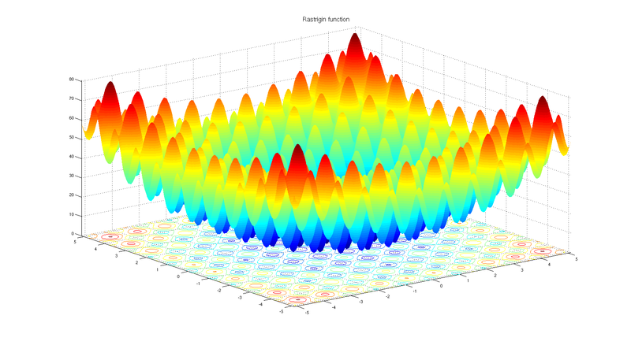

## Meta Heuristics:

A metaheuristic is a high-level problem-independent algorithmic framework that

provides a set of guidelines or strategies to develop heuristic optimization algorithms.

This area addresses to find best alternatives among given set of solutions of a particular problem. For this purpose, many optimizations techniques have been developed to find best alternatives. According to our limited knowledge, there is not even a single technique available that can give best solution for all kind of problems. Therefore, different techniques are used to address different problems depending upon their nature. To develop optimization techniques, researchers observe natural phenomenon and convert it into algorithms. One of the prominent examples is **Genetic Algorithm** which is inspired by biological evolution. **Ant Colony Optimization,** as the name indicates, is inspired by ant colonies. There are many examples like Gray Wolf Optimization, Particle Swarm Optimization, Gravitational Search Optimization, etc.

# Background and Justification:

There are many Nature inspired algorithms that are used to formulate many engineering, medical and industrial problems etc. There is algorithm on Wolves attacking, Dolphin echo-location, Tornedo, Whirlpool, Particle Swarm, Whale, Lion, Cuckoo, Bat etc. As far as we understood from these algorithms, every phenomenon in itself is based on optimization.

These algorithms provoked an idea to design a new algorithm on a phenomenon on which no algorithm has been mapped mathematically. This thought led us to design an algorithm or War Tactics (tactics that are used in Battlefield).

# Our proposed work:

## 3.1. Our Idea:

We are willing to develop an optimization algorithm. Inspiration we are using is **War Tactics.** There is no algorithm that is inspired by war tactics according to our knowledge. For that purpose, we will be studying several war tactics and map it into algorithm and then we would compare our algorithm with following well known algorithms:

* Genetic Algorithm
* Particle Swarm Optimization
* Gray Wolf Optimization
* Teacher Learning Algorithm
* Gravitational Search Algorithm

In order to compare our algorithm with above mentioned algorithms, we will compare these algorithms (Above algorithms can be changed) on an application. User can choose a particular algorithm and set its parameters and similarly, user can choose second algorithm as well and then their comparison will be shown in tabular and graphs form that includes convergence curves, trajectory. We would also test our algorithm on **benchmark functions.**

**Significance of our work**

* The proposed algorithm is based on war tactics and war strategies. With the help of our work, many engineering problems like may give optimized solution
* Our work would be shaped into publishable research paper.

## 3.2. Project Scope:

* Propose an algorithm
* Implementation of an Algorithm
* Perform Experiments
* Comparison Report
* Research paper writing

# Learning Outcomes:

* We would be able to model real-life problems as optimization problems.
* We would be able to choose a solution method appropriate to the characteristics of a given problem and obtain a solution.
* We would be able to implement optimization methods yields problems in numerical linear algebra.

# References:

<https://www.cs.auckland.ac.nz/courses/compsci367s1c/tutorials/IntroductionToWeka.pdf>

<http://mathworld.wolfram.com/GlobalOptimization.html>

<https://en.wikipedia.org/wiki/Metaheuristic>